LAB TASKS (Lab # 02)

Note: Prepare only truth tables for the following statements. Along with this
document, also attach circuit images of the 3 tasks completed in class
(hardware lab).
Lab Task 1: Implement a NOT gate using NAND gate only.
Circuit Description:
• Use one NAND gate
• Connect both inputs together (A tied with A)
Boolean Expression: Y = (A · A)’ = A’
A | A | (A.A)'
0 | 0 | 1
1 | 1 | 0

Lab Task 2: Implement an AND gate using NAND gates only (NAND–NAND
implementation).
Circuit Description:
• First NAND gives (A·B)’
• Second NAND acts as NOT (inputs tied)
Expression: Y = ((A·B)’)’ = A·B
A | B | (A.B)' | ((A.B)')' | A.B
0 | 0 | 1 | 0 | 0
0 | 1 | 1 | 0 | 0
1 | 0 | 1 | 0 | 0
1 | 1 | 0 | 1 | 1

Lab Task 3: Implement an OR gate using NAND gates only.
Circuit Description:
• Use two NAND gates as NOT on A and B
• Feed outputs to a NAND gate
Expression: Y = (A’·B’)’ = A + B
A | B | A' | B' | A'.B' | (A'.B')' | A+B
0 | 0 | 1 | 1 | 1 | 0 | 0
0 | 1 | 1 | 0 | 0 | 1 | 1
1 | 0 | 0 | 1 | 0 | 1 | 1
1 | 1 | 0 | 0 | 0 | 1 | 1

Lab Task 4: Implement a NOT gate using NOR gate only.
Circuit Description: Tie both inputs of NOR gate
Expression: Y = (A + A)’ = A’
A | A+A | (A+A)' | A'
0 | 0 | 1 | 1
1 | 1 | 0 | 0

Lab Task 5: Implement an OR gate using NOR gates only (NOR–NOR).
Circuit Description:
• First NOR gives (A+B)’
• Second NOR acts as NOT
Expression: Y = ((A+B)’)’ = A + B
A | B | A+B | (A+B)' | ((A+B)')'
0 | 0 | 0 | 1 | 0
0 | 1 | 1 | 0 | 1
1 | 0 | 1 | 0 | 1
1 | 1 | 1 | 0 | 1

Lab Task 6: Implement an AND gate using NOR gates only.
Circuit Description:
• Generate A’ and B’ using NOR
• NOR them again
Expression: Y = (A’ + B’)’ = A·B
A | B | A.B | A' | B' | A'+B' | (A'+B')'
0 | 0 | 0 | 1 | 1 | 1 | 0
0 | 1 | 0 | 1 | 0 | 1 | 0
1 | 0 | 0 | 0 | 1 | 1 | 0
1 | 1 | 1 | 0 | 0 | 0 | 1

Lab Task 7: Implement the Boolean function using NAND only:
Y=(A+B)(B+C)
A | B | C | A+B | B+C | (A+B)(B+C)
0 | 0 | 0 | 0 | 0 | 0
0 | 0 | 1 | 0 | 1 | 0
0 | 1 | 0 | 1 | 1 | 1
0 | 1 | 1 | 1 | 1 | 1
1 | 0 | 0 | 1 | 0 | 0
1 | 0 | 1 | 1 | 1 | 1
1 | 1 | 0 | 1 | 1 | 1
1 | 1 | 1 | 1 | 1 | 1

Lab Task 8: Implement the Boolean function using NOR only:
Y=(AB+C)’
A | B | C | AB | AB+C | (AB+C)'
0 | 0 | 0 | 0 | 0 | 1
0 | 0 | 1 | 0 | 1 | 0
0 | 1 | 0 | 0 | 0 | 1
0 | 1 | 1 | 0 | 1 | 0
1 | 0 | 0 | 0 | 0 | 1
1 | 0 | 1 | 0 | 1 | 0
1 | 1 | 0 | 1 | 1 | 0
1 | 1 | 1 | 1 | 1 | 0
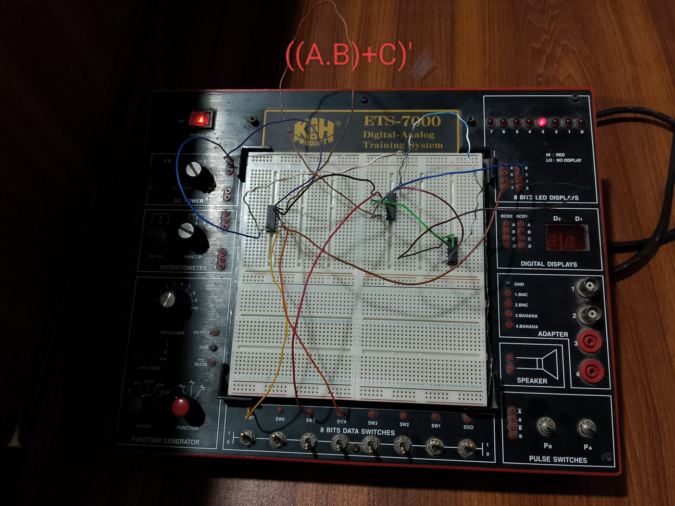

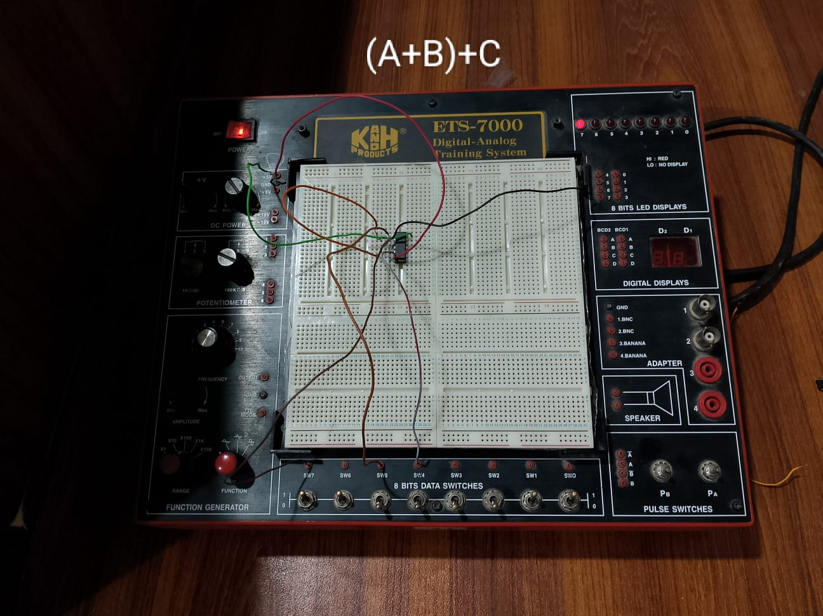

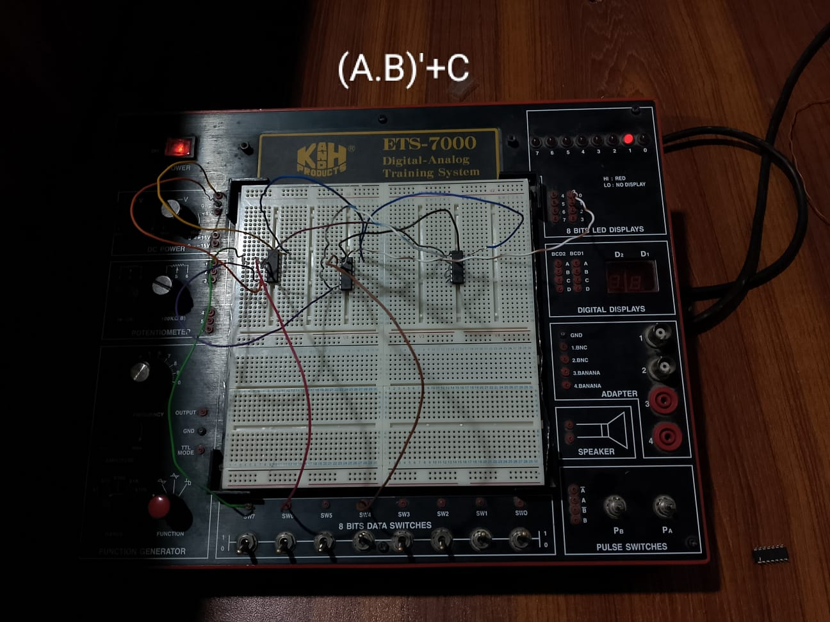
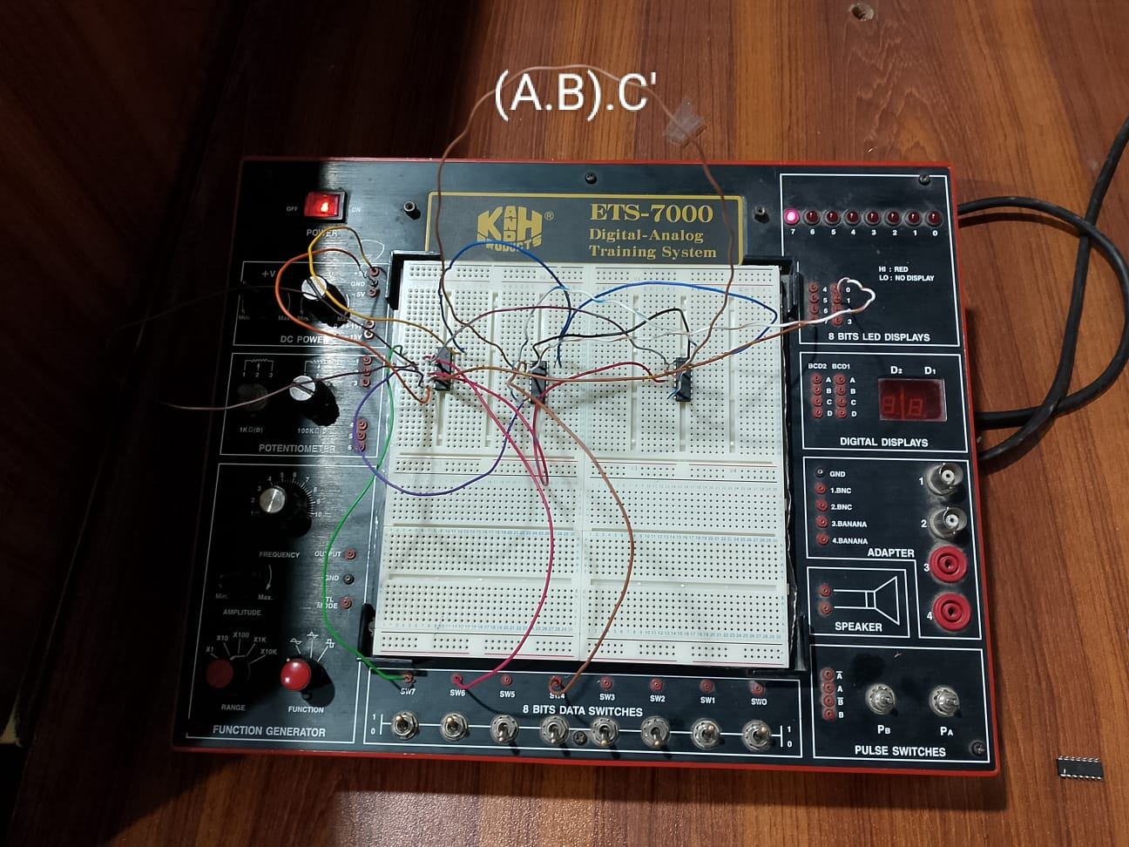

Dear sir 3rd and 4th pics would be looking like same although both are same I have done my these two questions at once using more wire so both Boolean equations are applied on the one pic so both pic are same for your clarity I have provided both pics

